The merging of computers and communications has had a profound influence on the way computer systems are organized. The once-dominant concept of the ‘‘computer center’’ as a room with a large computer to which users bring their work for processing is now totally obsolete (although data centers holding thousands of Internet servers are becoming common). The old model of a single computer serving all of the organization’s computational needs has been replaced by one in which a large number of separate but interconnected computers do the job. These systems are called computer networks.

USES OF COMPUTER NETWORKS
Most companies have a substantial number of computers. For example, a company may have a computer for each worker and use them to design products, write brochures, and do the payroll. Initially, some of these computers may have worked in isolation from the others, but at some point, management may have decided to connect them to be able to distribute information throughout the company. Put in slightly more general for, the issue here is resource sharing. The goal is to make all programs, equipment, and especially data available to anyone on the network without regard to the physical location of the resource or the user. An obvious and widespread example is having a group of office workers share a common printer. None of the individuals really needs a private printer, and a high-volume networked printer is often cheaper, faster, and easier to maintain than a large collection of individual printers. In the simplest of terms, one can imagine a company’s information system as consisting of one or more databases with company information and some number of employees who need to access them remotely. In this model, the data are stored on powerful computers called servers. Often these are centrally housed and maintained by a system administrator. In contrast, the employees have simpler machines, called clients, on their desks, with which they access remote data, for example, to include in spreadsheets they are constructing. (Sometimes we will refer to the human user of the client machine as the ‘‘client,’’ but it should be clear from the context whether we mean the computer or its user.) The client and server machines are connected by a network, as illustrated in Fig. 1-1. Note that we have shown the network as a simple oval, without any detail. We will use this form when we mean a network in the most abstract sense. When more detail is required, it will be provided.
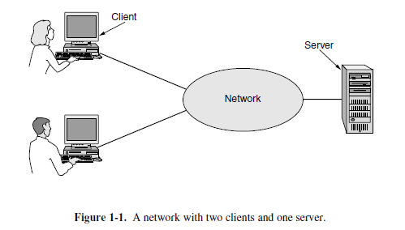
Home Applications
Internet access provides home users with connectivity to remote computers. As with companies, home users can access information, communicate with other people, and buy products and services with e-commerce. The main benefit now comes from connecting outside of the home

NETWORK HARDWARE
there are two types of transmission technology that are in widespread use: broadcast links and point-to-point links. Point-to-point links connect individual pairs of machines. To go from the
source to the destination on a network made up of point-to-point links, short messages, called packets in certain contexts, may have to first visit one or more intermediate machines. Often multiple routes, of different lengths, are possible, so finding good ones is important in point-to-point networks. Point-to-point transmission with exactly one sender and exactly one receiver is sometimes called unicasting.

Personal Area Networks
PANs (Personal Area Networks) let devices communicate over the range of a person. A common example is a wireless network that connects a computer with its peripherals. Almost every computer has an attached monitor, keyboard, mouse, and printer. Without using wireless, this connection must be done with cables. So many new users have a hard time finding the right cables and plugging them into the right little holes (even though they are usually color coded) that most computer vendors offer the option of sending a technician to the user’s home to do it. To help these users, some companies got together to design a short-range wireless network called Bluetooth to connect these components without wires. The idea is that if your devices have Bluetooth, then you need no cables. You just put them down, turn them on, and they work together. For many people, this ease of operation is a big plus.
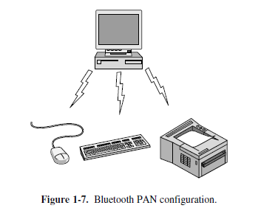

Local Area Networks
A LAN is a privately owned network that operates within and nearby a single building like a home, office or factory. LANs are widely used to connect personal computers and consumer
electronics to let them share resources (e.g., printers) and exchange information. When LANs are used by companies, they are called enterprise networks. Wireless LANs are very popular these days, especially in homes, older office buildings, cafeterias, and other places where it is too much trouble to install cables. In these systems, every computer has a radio modem and an antenna that it uses to communicate with other computers. In most cases, each computer talks
to a device in the ceiling as shown in Fig. 1-8(a). This device, called an AP (Access Point), wireless router, or base station, relays packets between the wireless computers and also between them and the Internet. Being the AP is like being the popular kid as school because everyone wants to talk to you. However, if other computers are close enough, they can communicate directly with one and another in a peer-to-peer configuration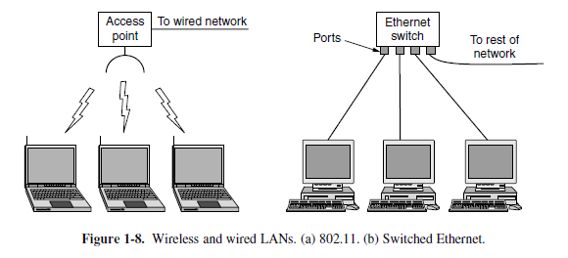

Metropolitan Area Networks
A MAN (Metropolitan Area Network) covers a city. The best-known examples of MANs are the cable television networks available in many cities. These systems grew from earlier community antenna systems used in areas with poor over-the-air television reception. In those early systems, a large antenna was placed on top of a nearby hill and a signal was then piped to the subscribers’ houses. At first, these were locally designed, ad hoc systems. Then companies began jumping into the business, getting contracts from local governments to wire up entire
cities. The next step was television programming and even entire channels designed for cable only. Often these channels were highly specialized, such as all news, all sports, all cooking, all gardening, and so on. But from their inception until the late 1990s, they were intended for television reception only.
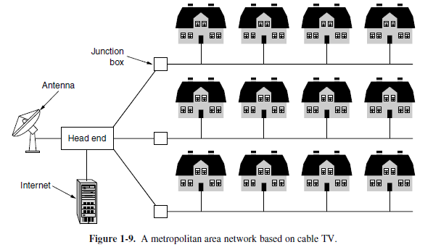
Wide Area Networks
A WAN (Wide Area Network) spans a large geographical area, often a country or continent. We will begin our discussion with wired WANs, using the example of a company with branch offices in different cities. In most WANs, the subnet consists of two distinct components: transmission lines and switching elements. Transmission lines move bits between machines.
They can be made of copper wire, optical fiber, or even radio links. Most companies do not have transmission lines lying about, so instead they lease the lines from a telecommunications company. Switching elements, or just switches, are specialized computers that connect two or more transmission lines. When data arrive on an incoming line, the switching element must choose an outgoing line on which to forward them. These switching computers have been called by various names in the past; the name router is now most commonly used.

NETWORK SOFTWARE
Basically, a protocol is an agreement between the communicating parties on how communication is to proceed. A five-layer network is illustrated in Fig. 1-13. The entities comprising the corresponding layers on different machines are called peers. The peers may be software processes, hardware devices, or even human beings. In other words, it is the peers that communicate by using the protocol to talk to each other.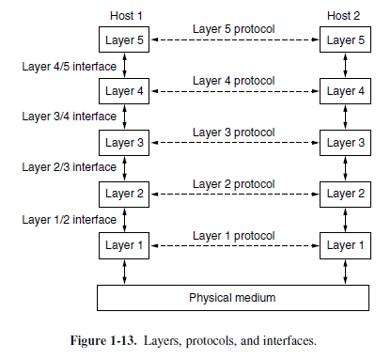
In reality, no data are directly transferred from layer n on one machine to layer n on another machine. Instead, each layer passes data and control information to the layer immediately below it, until the lowest layer is reached. Below layer 1 is the physical medium through which actual communication occurs. In Fig. 1-13, virtual communication is shown by dotted lines and physical communication by solid lines. Between each pair of adjacent layers is an interface. The interface defines which primitive operations and services the lower layer makes available to the upper one. When network designers decide how many layers to include in a network and what each one should do, one of the most important considerations is defining clean interfaces between the layers.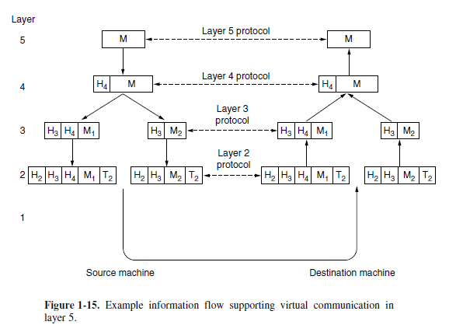

THE OSI MODEL
The Open Systems Interconnection (OSI) reference model was developed by the International Organization for Standardization (ISO) as a model for a computer protocol architecture and as a framework for developing protocol standards. The OSI model consists of seven layers:
• Application
• Presentation
• Session
• Transport
• Network
• Data link
• Physical Figure illustrates the OSI model and provides a brief definition of the functions performed at each layer. The intent of the OSI model is that protocols be developed to perform the functions of each layer.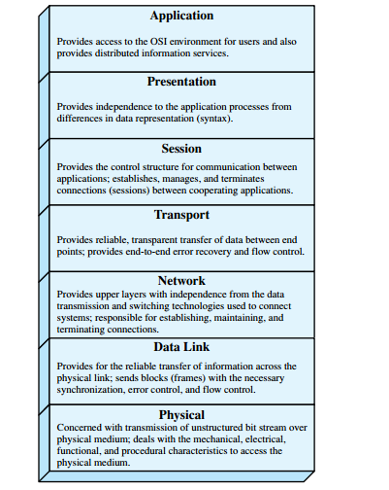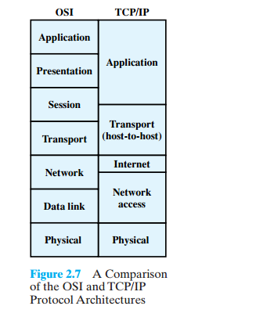

Data Link Layer
The data link layer transforms the physical layer, a raw transmission facility, to be liable link. It makes the physical layer appear error-free to the upper layer (network layer). Other responsibilities of the data link layer include the following:
I. Framing. The data link layer divides the stream of bits received from the network Layer into manage able data units called frames.
2. Physical addressing. If frames are to be distributed to different systems on the network, the data link layer adds a header to the frame to define the sender and or receiver of the frame. If the frame is intended for a system outside the sender's network, the receiver address is the address of the device that connects the network to the next one.
3 Flow control. If the rate at which the data are absorbed by the receiver is less than the rate at which data are produced in the sender, the data link layer imposes a flow control mechanism to avoid overwhelming the receiver.
4 Error control: The data link layer adds reliability to the physical layer by adding mechanisms to detect and retransmit damaged or lost frames. It also uses a mechanism to recognize duplicate frames. Error control is normally achieved through a trailer added to the end of the frame.
5 Access control: When two or more devices are connected to the same link, data link layer protocols are necessary to determine which device has control over the link at any given time
Network Layer:
The network layer is responsible for the source-to-destination delivery of a packet, possibly across multiple networks (links). Whereas the data link layer over sees the delivery of the packet between two systems on the same network (links), the network layer ensures that each packet gets from its point of origin to its final destination. If two systems are connected to the same link, there is usually no need for a network layer. However, if the two systems are attached to different networks (links) with connecting devices between the networks (links), there is often a need for the network Layer to accomplish source-to-destination delivery.
Transport Layer
The transport layer is responsible for process-to-process delivery of the entire message. A process is an application program running on a host. Whereas the network layer oversees source-to-destination delivery of individual packets, it does not recognize any relationship between those packets. It treats each one independently, as though each piece belonged to a separate message, whether or not it does. The transport layer, on the other hand, ensures that the whole message arrives intact and in order, overseeing both error control and flow control at the source-to-destination level. Other responsibilities of the transport layer include the following:
1 Service-point addressing. Computers often run several programs at the same time. For this reason, source-to-destination delivery means delivery not only from one computer to the next but also from a specific process (running program) on one computer to a specific process (running program) on the other. The transport layer header must therefore include a type of address called a service-point address (or port address). The network layer gets each packet to the correct computer; the transport layer gets the entire message to the correct process on that computer.
2 Segmentation and reassembly. A message is divided into transmittable segments, with each segment containing a sequence number. These numbers enable the transport layer to reassemble the message correctly upon arriving at the destination and to identify and replace packets that were lost in transmission.
3. Connectioncontrol.
The transport layer can be either connection less or connection oriented. A connectionless transport layer treats each segment as an independent packet and delivers it to the transport layer at the destination machine. A connection oriented transport layer makes a connection with the transport layer at the destination machine first before delivering the packets. After all the data are transferred, the connection is terminated.
4. Flowcontrol. Like the data link layer, the transport layer is responsible for flow control. However, flow control at this layer is performed end to end rather than across a single link.
5. Errorcontrol. Like the data link layer, the transport layer is responsible for error control. However, error control at this layer is performed process-to process rather than across a single link. The sending transport layer makes sure that the entire message arrives at the receiving transport layer without error (damage, loss, or duplication). Error correction is usually achieved through retransmission.
Session Layer
The services provided by the first three layers (physical, data link, and network) are not sufficient for some processes. The session layer is the network dialog controller. It establishes, maintains, and synchronizes the interaction among communicating systems. Specific responsibilities of the session layer include the following:
1. Dialog control. The session layer allows two systems to enter into a dialog. It allows the communication between two processes to take place in either half duplex (one way at a time) or full-duplex (two ways at a time) mode.
2. Synchronization.Thesessionlayer allows a process to add check points, or synchronization points, to a stream of data. For example, if a system is sending a file of 2000pages, it is advisable to insertcheckpointsafterevery100pagesto ensure thateach100-pageunitis received and acknowledged independently. In this case, if a crash happens during the transmission ofpage523, the only pages that need to be resent after system recovery are pages501 to 523.Pages previous to 501 need not be resent
Presentation Layer
The presentation layer is concerned with the syntax and semantics of the information Exchanged between two systems Specific responsibilities of the presentation layer include the following:
1 Translation .The processes (running programs) in two systems are usually exchanging information in the form of character strings, numbers, and soon. The information must be changed to bit streams before being transmitted. Because different computers use different encoding systems, the presentation layer is responsible for interoperability between these different encoding methods. The presentation layer at the sender changes the information from its sender-dependent format into a common format. The presentation layer at the receiving machine changes the common format into its receiver-dependent format.
2. Encryption. To carry sensitive information, a system must be able to ensure privacy. Encryption means that the sender transforms the original information to another form and sends the resulting message out over the network. Decryption reverses the original process to transform the message back to its original form.
3. Compression. Data compression reduces the number of bits contained in the information. Data compression becomes particularly important in the transmission of multimedia such as text, audio, and video.
Application Layer
The application layer enables the user, whether human or software, to access the network. It provides user interfaces and support for services such as electronic mail, remote file access and transfer, shared database management, and other types of distributed information services
Specific services provided by the application layer include the following:
1. Network virtual terminal. A network virtual terminal is a software version of a physical terminal, and it allows a user to log onto a remote host. To do so, the application creates a software emulation of a terminal at the remote host. The user's computer talks to the software terminal which, in turn, talks to the host and vice versa. The remote host believes it is communicating with one of its own terminals and allows the user to log on.
2. File transfer, access, and management. This application allows a user to access files in a remote host (to make changes or read data), to retrieve files from a remote computer for use in the local computer, and to manage or control files in a remote computer locally.
3. Mail services. This application provides the basis for e-mail forwarding and storage.
4. Directory services. This application provides distributed database sources and access for global information about various objects and services
The TCP/IP Reference Model
The ARPANET, and its successor, the worldwide Internet. Although we will give a brief history of the ARPANET later, it is useful to mention a few key aspects of it now. The ARPANET was a research network sponsored by the DoD (U.S. Department of Defense). It eventually connected hundreds of universities and government installations, using leased telephone lines. When satellite and radio networks were added later, the existing protocols had trouble interworking with them, so new reference architecture was needed. Thus, from nearly the beginning, the ability to connect multiple networks in a seamless way was one of the major design goals.
This architecture later became known as the TCP/IP Reference Model, after its two primary protocols

The Link Layer
All these requirements led to the choice of a packet-switching network based on a connectionless layer that runs across different networks. The lowest layer in the model, the link layer describes what links such as serial lines and classic Ethernet must do to meet the needs of this connectionless internet layer. It is not really a layer at all, in the normal sense of the term, but rather an interface between hosts and transmission links. Early material on the TCP/IP model has little to say about it.

The Internet Layer
The internet layer is the linchpin that holds the whole architecture together. It is shown in Fig. 1-21 as corresponding roughly to the OSI network layer. Its job is to permit hosts to inject packets into any network and have they travel independently to the destination (potentially on a different network). They may even arrive in a completely different order than they were sent, in which case it is the job of higher layers to rearrange them, if in-order delivery is desired. Note
that ‘‘internet’’ is used here in a generic sense, even though this layer is present in the Internet.
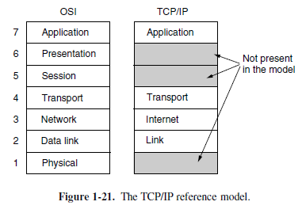
The internet layer defines an official packet format and protocol called IP (Internet Protocol), plus a companion protocol called ICMP (Internet Control Message Protocol) that helps it function. The job of the internet layer is to deliver IP packets where they are supposed to go. Packet routing is clearly a major issue here, as is congestion (though IP has not proven effective at avoiding congestion).

The Transport Layer
The layer above the internet layer in the TCP/IP model is now usually called the transport layer. It is designed to allow peer entities on the source and destination hosts to carry on a conversation, just as in the OSI transport layer. Two end-to-end transport protocols have been defined here. The first one, TCP (Transmission Control Protocol), is a reliable connection-oriented protocol that allows a byte stream originating on one machine to be delivered without error on any other machine in the internet. It segments the incoming byte stream into discrete messages and passes each one on to the internet layer. At the destination, the receiving TCP process reassembles the received messages into the output stream. TCP also handles flow control to make sure a fast sender cannot swamp a slow receiver with more messages than it can handle. The second protocol in this layer, UDP (User Datagram Protocol), is an unreliable, connectionless protocol for applications that do not want TCP’s sequencing or flow control and wish to provide their own. It is also widely used for one-shot, client-server-type request-reply queries and applications in which prompt delivery is more important than accurate delivery, such as transmitting speech or video.

The Application Layer
The TCP/IP model does not have session or presentation layers. No need for them was perceived. Instead, applications simply include any session and presentation functions that they require. Experience with the OSI model has proven this view correct: these layers are of little use to most applications. On top of the transport layer is the application layer. It contains all the higher- level protocols. The early ones included virtual terminal (TELNET), file transfer
(FTP), and electronic mail (SMTP). Many other protocols have been added to these over the years.
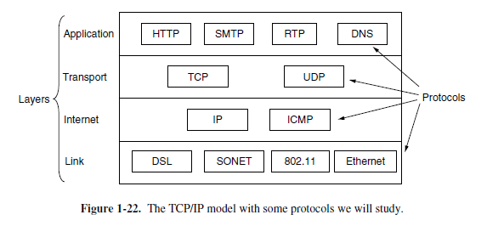

THE PHYSICAL LAYER
The physical layer. It defines the electrical, timing and other interfaces by which bits are sent as signals over channels. The physical layer is the foundation on which the network is built. The properties of different kinds of physical channels determine the performance

THE THEORETICAL BASIS FOR DATA COMMUNICATION
Information can be transmitted on wires by varying some physical property such as voltage or current. By representing the value of this voltage or current as a single-valued function of time, f (t), we can model the behavior of the signal and analyze it mathematically. This analysis is the subject of the following sections.

Fourier analysis
In the early 19th century, the French mathematician Jean-Baptiste Fourier proved that any reasonably behaved periodic function, g(t) with period T, can be constructed as the sum of a (possibly infinite) number of sines and cosines:
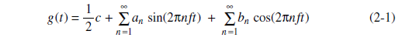
where f  1/T is the fundamental frequency, an and bn are the sine and cosine amplitudes
of the nth harmonics (terms), and c is a constant. Such decomposition is called a Fourier series. From the Fourier series, the function can be reconstructed. That is, if the period, T, is known and the amplitudes are given, the original function of time can be found by performing the sums of Eq. (2-1). A data signal that has a finite duration, which all of them do, can be handled by just imagining that it repeats the entire pattern over and over forever (i.e., the
Interval from T to 2T is the same as from 0 to T, etc.). The an amplitudes can be computed for any given g(t) by multiplying both sides of Eq. (2-1) by sin(2⇨kft ) and then integrating from 0 to T.
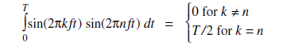
TRANSMISSION IMPAIRMENTS
With any communications system, the signal that is received may differ from the signal that is transmitted due to various transmission impairments. For analog signals, these impairments can degrade the signal quality. For digital signals, bit errors maybe introduced, such that a binary 1 is transformed into a binary 0 or vice versa. In this section, we examine the various impairments and how they may affect the information-carrying capacity of a communication link; the most significant impairments are
• Attenuation and attenuation distortion
• Delay distortion
• Noise
Attenuation
The strength of a signal falls off with distance over any transmission medium. For guided media, this reduction in strength, or attenuation, is generally exponential and thus is typically expressed as a constant number of decibels per unit distance. For unguided media, attenuation is a more complex function of distance and the makeup of the atmosphere. Attenuation introduces three considerations for the transmission engineer. First, a received signal must have sufficient strength so that the electronic circuitry in the receiver can detect the signal. Second, the signal must maintain a level sufficiently higher than noise to be received without error. Third, attenuation varies with frequency. The first and second problems are dealt with by attention to signal strength and the use of amplifiers or repeaters. For a point-to-point link, the signal strength of the transmitter must be strong enough to be received intelligibly, but not so strong as to overload the circuitry of the transmitter or receiver, which would cause distortion. Beyond a certain distance, the attenuation becomes unacceptably great, and repeaters or amplifiers are used to boost the signal at regular intervals. These problems are more complex for multipoint lines where the distance from transmitter to receiver is variable. The third problem is particularly noticeable for analog signals. Because the attenuation varies as a function of frequency, the received signal is distorted, reducing intelligibility.To overcomes this problem, and techniques are available for equalizing attenuation across a band of frequencies. This is commonly done for voice-grade telephone lines by using loading coils that change the electrical properties of the line; the result is to smooth out attenuation effects. Another approach is to use amplifiers that amplify high frequencies more than lower frequencies. An example is provided in Figure 3.15a, which shows attenuation as a function of frequency for a typical leased line. In the figure, attenuation is measured relative to the attenuation at 1000 Hz. Positive values on the y-axis represent attenuation greater than that at 1000 Hz. A 1000-Hz tone of a given power level is applied to the input, and the power, is measured at the output. For any other frequency f, the
procedure is repeated and the relative attenuation in decibels is8
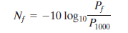
Delay Distortion
Delay distortion occurs because the velocity of propagation of a signal through guided medium varies with frequency. For a band limited signal, the velocity tends tobe highest near the center frequency and fall off toward the two edges of the band. Thus various frequency components of a signal will arrive at the receiver at different times, resulting in phase shifts between the different frequencies. This effect is referred to as delay distortion because the received signal is distorted due to varying delays experienced at its constituent frequencies. Delay distortion is particularly critical for digital data. Consider that a sequence of bits is being transmitted, using either analog or digital signals. Because of delay distortion, some of the signal components of one bit position will spill over into other bit positions, causing intersymbol interference, which is a major limitation to maximum bit rate over a transmission channel.

Noise
For any data transmission event, the received signal will consist of the transmittedsignal, modified by the various distortions imposed by the transmission system, plusadditional unwanted signals that are inserted somewhere between transmission andreception. The latter, undesired signals are referred to as noise. Noise is the majorlimiting factor in communications system performance.Noise may be divided into four categories:
• Thermal noise
• Intermodulation noise
• Crosstalk
• Impulse noise
Thermal noise is due to thermal agitation of electrons. It is present in all electronic devices and transmission media and is a function of temperature. Thermal noise is uniformly distributed across the bandwidths typically used in communications systems and hence is often referred to as white noise. Thermal noise cannot be eliminated and therefore places an upper bound on communications system performance. Because of the weakness of the signal received by satellite earth stations, thermal noise is particularly significant for satellite communication.
The amount of thermal noise to be found in a bandwidth of 1 Hz in any device
or conductor is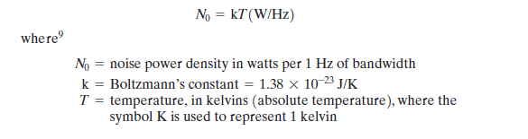
When signals at different frequencies share the same transmission medium, the result may be intermodulation noise. The effect of intermodulation noise is to produce signals at a frequency that is the sum or difference of the two original frequencies or multiples of those frequencies. For example, the mixing of signals at frequencies and might produce energy at the frequency this derived signal could interfere with an intended signal at the frequencyIntermodulation noise is produced by nonlinearities in the transmitter, receiver, and/or intervening transmission medium. Ideally, these components behave as linear systems; that is, the output is equal to the input times a constant. However, in any real system, the output is a more complex function of the input. Excessive nonlinearity can be caused by component malfunction or overload from excessive signal strength. It is under these circumstances that the sum and difference frequency terms occur.
Crosstalk has been experienced by anyone who, while using the telephone, has been able to hear another conversation; it is an unwanted coupling between signal paths. It can occur by electrical coupling between nearby twisted pairs or, rarely, coax cable lines carrying multiple signals. Crosstalk can also occur when microwave antennas pick up unwanted signals; although highly directional antennas are used, microwave energy does spread during propagation. Typically, crosstalk is of the same order of magnitude as, or less than, thermal noise. All of the types of noise discussed so far have reasonably predictable and relatively constant magnitudes. Thus it is possible to engineer a transmission system tocope with them. Impulse noise, however, is noncontinuous, consisting of irregular pulses or noise spikes of short duration and of relatively high amplitude. It is generated from a variety of causes, including external electromagnetic disturbances, such as lightning, and faults and flaws in the communications system. Impulse noise is generally only a minor annoyance for analog data.
CHANNEL CAPACITY
We have seen that there are a variety of impairments that distort or corrupt a signal. For digital data, the question that then arises is to what extent these impairments limit the data rate that can be achieved. The maximum rate at which data can be transmitted over a given communication path, or channel, under given conditions, is referred to as the channel capacity.

There are four concepts here that we are trying to relate to one another.
• Data rate: The rate, in bits per second (bps), at which data can be communicated
• Bandwidth: The bandwidth of the transmitted signal as constrained by the transmitter and the nature of the transmission medium, expressed in cycles per second, or Hertz
• Noise: The average level of noise over the communications path
• Error rate: The rate at which errors occur, where an error is the reception of a
1 when a 0 was transmitted or the reception of a 0 when a 1 was transmitted

GUIDED TRANSMISSION MEDIA

For guided transmission media, the transmission capacity, in terms of either data rate or bandwidth, depends critically on the distance and on whether the medium is point-to-point or multipoint The three guided media commonly used for data transmission are twisted pair, coaxial cable, and optical fiber Twisted Pair The least expensive and most widely used guided transmission medium is twisted pair.
Physical Description A twisted pair consists of two insulated copper wires arranged in a regular spiral pattern. A wire pair acts as a single communication link. Typically, a number of these pairs are bundled together into a cable by wrapping them in a tough protective sheath. Over longer distances, cables may contain hundreds of pairs. The twisting tends to decrease the crosstalk interference between adjacent pairs in a cable. Neighboring pairs in a bundle typically have somewhat different twist lengths to reduce the crosstalk interference. On long-distance links, the
twist length typically varies from 5 to 15 cm.The wires in a pair have thicknesses of from 0.4 to 0.9 mm.
Applications By far the most common guided transmission medium for both analog and digital signals is twisted pair. It is the most commonly used medium in the telephone network and is the workhorse for communications within buildings. In the telephone system, individual residential telephone sets are connected to the local telephone exchange, or “end office,” by twisted-pair wire. These are referred to as subscriber loops. Within an office building, each telephone is also connected to a twisted pair, which goes to the in-house private branch exchange (PBX) system or to a Centrex facility at the end office. These twisted-pair installations were designed to support voice traffic using analog signaling. However, by means of a modem, these facilities can handle digital data traffic at modest data rates. Twisted pair is also the most common medium used for digital signaling. For connections to a digital data switch or digital PBX within a building, a data rate of 64 kbps is common. Twisted pair is also commonly used within a building for local
area networks supporting personal computers. Data rates for such products are typically in the neighborhood of 100 Mbps.
Transmission Characteristics Twisted pair may be used to transmit both analog and digital transmission. For analog signals, amplifiers are required about every 5 to 6 km. For digital transmission (using either analog or digital signals), repeaters are required every 2 or 3 km.
Compared to other commonly used guided transmission media (coaxial cable, optical fiber), twisted pair is limited in distance, bandwidth, and data rate. As Figure 4.3a shows, the attenuation for twisted pair is a very strong function of frequency. Other impairments are also severe for twisted pair. The medium is quite susceptible to interference and noise because of its easy coupling with electromagnetic fields. For example, a wire run parallel to an ac power line will pick up 60-Hz energy. Impulse noise also easily intrudes into twisted pair. Several measures are taken to reduce impairments. Shielding the wire with metallic braid or sheathing reduces interference. The twisting of the wire reduces low-frequency interference, and the use of different twist lengths in adjacent pairs reduces crosstalk. For point-to-point analog signaling, a bandwidth of up to about 1 MHz is possible. This accommodates a number of voice channels. For long-distance digital point-to-point signaling, data rates of up to a few Mbps are possible; for very short distances, data rates of up to 10 Gbps have been achieved in commercially available
products.
Unshielded and Shielded Twisted Pair twisted pair comes in two varieties: unshielded and shielded. Unshielded twisted pair (UTP) is ordinary telephone wire. Office buildings, by universal practice, are prewired with excess unshielded twisted pair, more than is needed for simple telephone support. This is the least expensive of all the transmission media commonly used for local area networks and is easy to work with and easy to install. Unshielded twisted pair is subject to external electromagnetic interference, including interference from nearby twisted pair and from noise generated in the environment. A way to improve the characteristics of this medium is to shield the twisted pair with a metallic braid or sheathing that reduces interference. This shielded twisted pair (STP) provides better performance at higher data rates. However, it is more Category 3 and Category 5 UTP Most office buildings are prewired with a
Type of 100-ohm twisted pair cable commonly referred to as voice grade. Because voice-grade twisted pair is already installed, it is an attractive alternative for use as a LAN medium. Unfortunately, the data rates and distances achievable with voice grade twisted pair are limited.
In 1991, the Electronic Industries Association published standard EIA-568, Commercial Building Telecommunications Cabling Standard, which specifies the use of voice-grade unshielded twisted pair as well as shielded twisted pair for in-building data applications. At that time, the specification was felt to be adequate for the range of frequencies and data rates found in office environments. Up to that time, the principal interest for LAN designs was in the range of data rates from 1 Mbps to 16 Mbps. Subsequently, as users migrated to higher-performance workstations and applications, there was increasing interest in providing LANs that could operate up to 100 Mbps over inexpensive cable. In response to this need, EIA-568-A was issued in 1995.The new standard reflects advances in cable and connector design and test methods.
It covers 150-ohm shielded twisted pair and 100-ohm unshielded twisted pair. EIA-568-A recognizes three categories of UTP cabling:
• Category 3: UTP cables and associated connecting hardware whose transmission
Characteristics are specified up to 16 MHz
• Category 4: UTP cables and associated connecting hardware whose transmission
Characteristics are specified up to 20 MHz
• Category 5: UTP cables and associated connecting hardware whose transmission
Characteristics are specified up to 100 MHz
Expensive and more difficult to work with than unshielded twisted pair
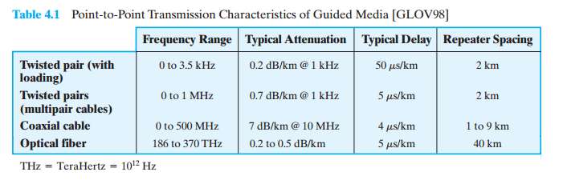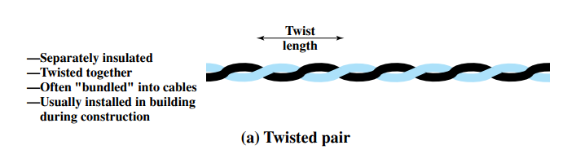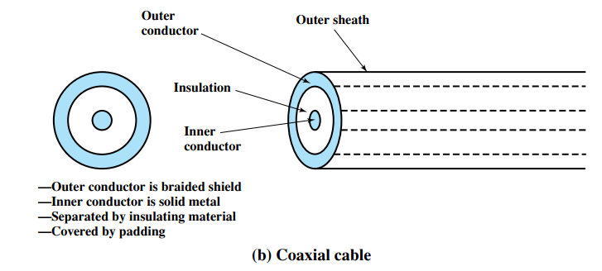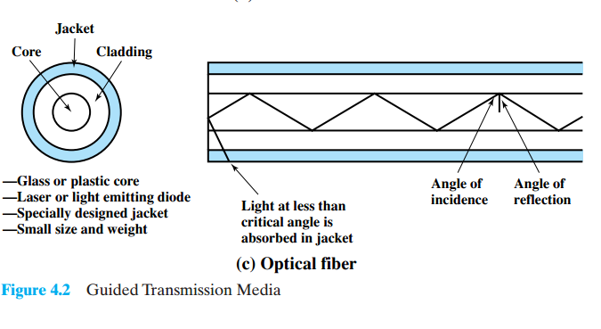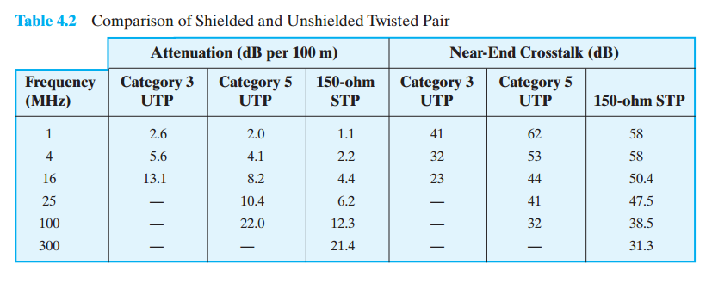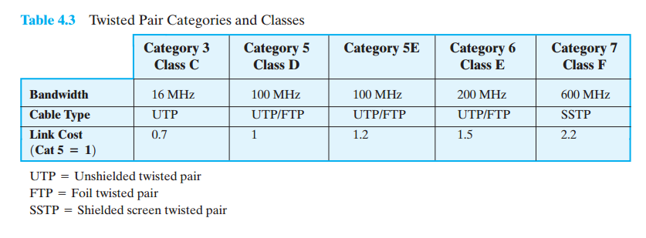

Coaxial Cable

Physical Description Coaxial cable, like twisted pair, consists of two conductors, but is constructed differently to permit it to operate over a wider range of frequencies. It consists of a hollow outer cylindrical conductor that surrounds a single inner wire conductor (Figure 4.2b). The inner conductor is held in place by either regularly spaced insulating rings or a solid dielectric material. The outer conductor is covered with a jacket or shield. A single coaxial cable has a diameter of from 1 to 2.5 cm. Coaxial cable can be used over longer distances and support more stations on a shared line than twisted pair.

Applications Coaxial cable is a versatile transmission medium, used in a wide
Variety of applications. The most important of these are
• Television distribution
• Long-distance telephone transmission
• Short-run computer system links
• Local area networks
Coaxial cable is widely used as a means of distributing TV signals to individual homes—cable TV. From its modest beginnings as Community Antenna Television (CATV), designed to provide service to remote areas, cable TV reaches almost as many homes and offices as the telephone. A cable TV system can carry dozens or even hundreds of TV channels at ranges up to a few tens of kilometers. Coaxial cable has traditionally been an important part of the long-distance telephone network. Today, it faces increasing competition from optical fiber, terrestrial microwave, and satellite. Using frequency division multiplexing, a coaxial cable can carry over 10,000 voice channels simultaneously. Coaxial cable is also commonly used for short-range connections between devices. Using digital signaling, coaxial cable can be used to provide high-speed I/O channels on computer systems.

Transmission Characteristics Coaxial cable is used to transmit both analog and digital signals. As can be seen from Figure 4.3b, coaxial cable has frequency characteristics that are superior to those of twisted pair and can hence be used effectively at higher frequencies and data rates. Because of its shielded, concentric construction, coaxial cable is much less susceptible to interference and crosstalk than twisted pair. The principal constraints on performance are attenuation, thermal noise, and intermodulation noise. The latter is present only when several channels (FDM) or frequency bands are in use on the cable. For long-distance transmission of analog signals, amplifiers are needed every few kilometers, with closer spacing required if higher frequencies are used. The usable spectrum for analog signaling extends to about 500 MHz for digital signaling; repeaters are needed every kilometer or so, with closer spacing needed for higher data rates.

Optical Fiber
Physical Description An optical fiber is a thin flexible medium capable of guiding an optical ray. Various glasses and plastics can be used to make optical fibers. The lowest losses have been obtained using fibers of ultrapure fused silica. Ultrapure fiber is difficult to manufacture; higher-loss multicomponent glass fibers are more economical and still provide good performance. Plastic fiber is even less costly and can be used for short-haul links, for which moderately high losses are acceptable.

An optical fiber cable has a cylindrical shape and consists of three concentric sections: the core, the cladding, and the jacket (Figure 4.2c). The core is the innermost section and consists of one or more very thin strands, or fibers, made of glass or plastic; the core has a diameter in the range of 8 to Each fiber is surrounded by its own cladding, a glass or plastic coating that has optical properties different from those of the core and a diameter of the interface between the core
and cladding acts as a reflector to confine light that would otherwise escape the core. The outermost layer, surrounding one or a bundle of cladded fibers, is the jacket. The jacket is composed of plastic and other material layered to protect against moisture, abrasion, crushing, and other environmental dangers.

Applications Optical fiber already enjoys considerable use in long-distance telecommunications, and its use in military applications is growing. The continuing improvements in performance and decline in prices, together with the inherent advantages of optical fiber, have made it increasingly attractive for local area networking. The following characteristics distinguish optical fiber from twisted pair or coaxial cable:
• Greater capacity: The potential bandwidth, and hence data rate, of optical fiber is immense; data rates of hundreds of Gbps over tens of kilometers have been demonstrated. Compare this to the practical maximum of hundreds of Mbps over about 1 km for coaxial cable and just a few Mbps over 1 km or up to 100 Mbps to 10 Gbps over a few tens of meters for twisted pair.
• Smaller size and lighter weight: Optical fibers are considerably thinner than coaxial cable or bundled twisted-pair cable—at least an order of magnitude thinner for comparable information transmission capacity. For cramped conduits in buildings and underground along public rights-of-way, the advantage of small size is considerable. The corresponding reduction in weight reduces structural support requirements.
• Lower attenuation: Attenuation is significantly lower for optical fiber than for coaxial cable or twisted pair (Figure 4.3c) and is constant over a wide range.
• Electromagnetic isolation: Optical fiber systems are not affected by external electromagnetic fields. Thus the system is not vulnerable to interference, impulse noise, or crosstalk. By the same token, fibers do not radiate energy, so there is little interference with other equipment and there is a high degree of security from eavesdropping. In addition, fiber is inherently difficult to tap.
• Greater repeater spacing: Fewer repeaters mean lower cost and fewer sources of error. The performance of optical fiber systems from this point of view has been steadily improving. Repeater spacing in the tens of kilometers for optical fiber is common, and repeater spacing’s of hundreds of kilometers have been demonstrated. Coaxial and twisted-pair systems generally have repeaters every few kilometers. Five basic categories of application have become important for optical fiber:
• Long-haul trunks
• Metropolitan trunks
• Rural exchange trunks
• Subscriber loops
• Local area networks
Three general ranges of frequencies are of interest in our discussion of wireless transmission.
Frequencies in the range of about 1 GHz to 40 GHz are referred to as microwave frequencies. At these frequencies, highly directional beams are possible, and microwave is quite suitable for point-to-point transmission. Microwave is also used for satellite communications. Frequencies in the range of 30 MHz to 1 GHz are suitable for omnidirectional applications. We refer to this range as the radio range. Another important frequency range, for local applications, is the infrared portion of the spectrum. This covers, roughly, from to Infrared is useful to local point-to-point and multipoint applications within confined areas, such as a single room. For unguided media, transmission and reception are achieved by means of an antenna. Before looking at specific categories of wireless transmission, we provide a brief introduction to antennas.
Antennas
An antenna can be defined as an electrical conductor or system of conductors used either for radiating electromagnetic energy or for collecting electromagnetic energy. For transmission of a signal, radio-frequency electrical energy from the transmitter is converted into electromagnetic energy by the antenna and radiated into the surrounding environment (atmosphere, space, water). For reception of a signal, electromagnetic energy impinging on the antenna is converted into radio-frequency electrical energy and fed into the receiver

Terrestrial Microwave
Physical Description The most common type of microwave antenna is the parabolic “dish.”A typical size is about 3 m in diameter. The antenna is fixed rigidly and focuses a narrow beam to achieve line-of-sight transmission to the receiving antenna. Microwave antennas are usually located at substantial heights above ground level to extend the range between antennas and to be able to transmit over intervening obstacles. To achieve long-distance transmission, a series of microwave relay towers is used, and point-to-point microwave links are strung together over
the desired distance.
Applications The primary use for terrestrial microwave systems is in long-haul telecommunications service, as an alternative to coaxial cable or optical fiber. The
microwave facility requires far fewer amplifiers or repeaters than coaxial cable over the same distance but requires line-of-sight transmission. Microwave is commonly used for both voice and television transmission

Satellite Microwave
Physical Description A communication satellite is, in effect, a microwave relay station. It is used to link two or more ground-based microwave transmitter/ receivers, known as earth stations, or ground stations. The satellite receives transmissions on one frequency band (uplink), amplifies or repeats the signal, and transmits it on another frequency (downlink). A single orbiting satellite will operate on a number of frequency bands, called transponder channels, or simply transponders.
Applications The following are among the most important applications for satellites:
• Television distribution
• Long-distance telephone transmission
• Private business networks
• Global positioning
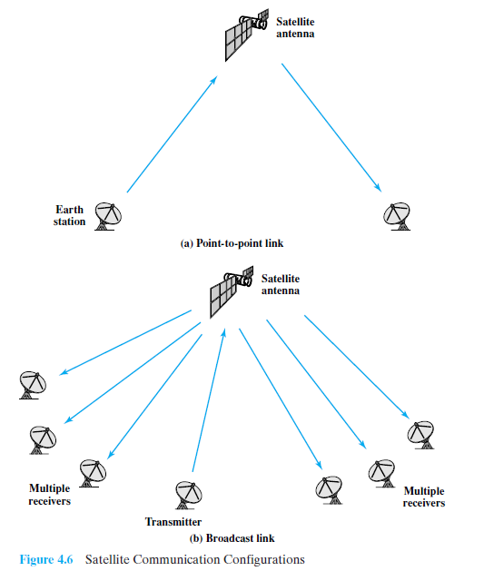
Broadcast Radio
Physical Description The principal difference between broadcast radio and microwave is that the former is omnidirectional and the latter is directional. Thus broadcast radio does not require dish-shaped antennas, and the antennas need not be rigidly mounted to a precise alignment.
Applications Radio is a general term used to encompass frequencies in the range of 3 kHz to 300 GHz. We are using the informal term broadcast radio to cover the VHF and part of the UHF band: 30 MHz to 1 GHz. This range covers FM radio and UHF and VHF television. This range is also used for a number of data networking applications.

SIGNAL ENCODING TECHNIQUES
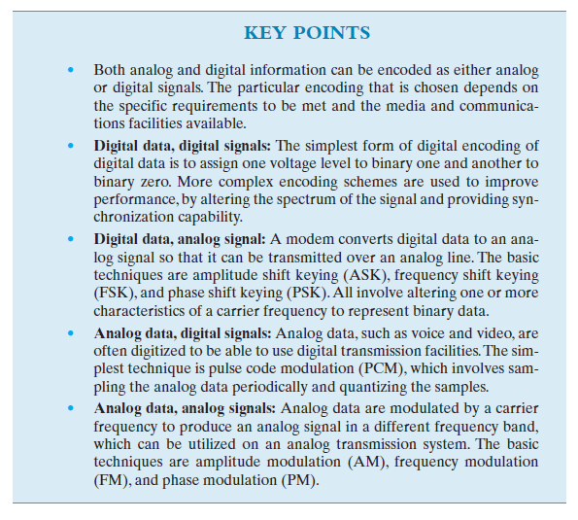
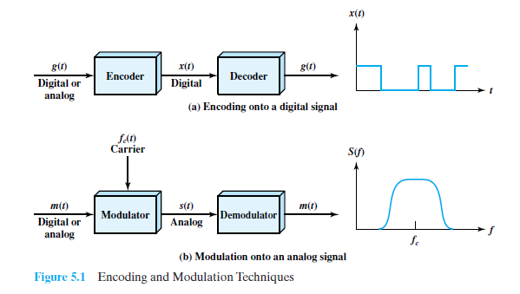
DIGITAL DATA, DIGITAL SIGNALS
A digital signal is a sequence of discrete, discontinuous voltage pulses. Each pulse is a signal element. Binary data are transmitted by encoding each data bit into signal elements. In the simplest case, there is a one-to-one correspondence between bits and signal elements in which binary 1 is represented by a lower voltage level and binary 0 by a higher voltage level
Nonreturn to Zero (NRZ)
The most common, and easiest, way to transmit digital signals is to use two different voltage levels for the two binary digits. Codes that follow this strategy share the property that the voltage level is constant during a bit interval; there is no transition (no return to a zero voltage level). For example, the absence of voltage can be used to represent binary 0, with a constant positive voltage used to represent binary 1. More commonly, a negative voltage represents one binary value and a positive voltage represents the other. This latter code, known as Nonreturn to Zero-Level
A variation of NRZ is known as NRZI (Nonreturn to Zero, invert on ones). As with NRZ-L, NRZI maintains a constant voltage pulse for the duration of a bit time. The data themselves are encoded as the presence or absence of a signal transition at the beginning of the bit time. A transition (low to high or high to low) at the beginning of a bit time denotes a binary 1 for that bit time; no transition indicates a binary 0.
NRZI is an example of differential encoding. In differential encoding, the information to be transmitted is represented in terms of the changes between successive signal elements rather than the signal elements themselves. The encoding of the current bit is determined as follows: If the current bit is a binary 0, then the current bit is encoded with the same signal as the preceding bit; if the current bit is a binary 1, then the current bit is encoded with a different signal than the preceding bit.
the bipolar-AMI scheme, a binary 0 is represented by no line signal, and a binary 1 is represented by a positive or negative pulse. The binary 1pulses must alternate in polarity. There are several advantages to this approach. First, there will be no loss of synchronization if a long string of 1s occurs. Each 1 introduces a transition, and the receiver can resynchronize on that transition. A long string of 0s would still be a problem. Second, because the 1 signals alternate in
voltage from positive to negative, there is no net dc component pseudo ternary. In this case, it is the binary 1 that is represented by the absence of a line signal, and the binary 0 by alternating positive and negative pulses. There is no particular advantage of one technique versus the other, and each is the basis of some applications. Although a degree of synchronization is provided with these codes, a long string of 0s in the case of AMI or 1s in the case of pseudo ternary still presents a problem. Several techniques have been used to address this deficiency. One approach is to insert additional bits that force transitions. This technique is used in ISDN (integrated services digital network) for relatively low data rate transmission. Of course, at a high data rate, this scheme is expensive, because it results in an increase in an already high signal transmission rate.

Biphase
There is another set of coding techniques, grouped under the term biphase that overcomes the limitations of NRZ codes. Two of these techniques, Manchester and differential Manchester, are in common use. In the Manchester code, there is a transition at the middle of each bit period.
The midbit transition serves as a clocking mechanism and also as data: a low-to-high transition represents a 1, and a high-to-low transition represents a 0.4 in differential Manchester, the midbit transition is used only to provide clocking. The encoding of a 0 is represented by the presence of a transition at the beginning of a bit period, and a 1 is represented by the absence of a transition at the beginning of a bit period. Differential Manchester has the added advantage of employing differential encoding. All of the biphase techniques require at least one transition per bit time and may have as many as two transitions. Thus, the maximum modulation rate is twice
that for NRZ; this means that the bandwidth required is correspondingly greater. On the other hand, the biphase schemes have several advantages:
• Synchronization: Because there is a predictable transition during each bit time, the receiver can synchronize on that transition. For this reason, the biphase codes are known as self-clocking codes.
• No dc component: Biphase codes have no dc component, yielding the benefits described earlier.
• Error detection: The absence of an expected transition can be used to detect errors. Noise on the line would have to invert both the signal before and after the expected transition to cause an undetected error.

Scrambling Techniques
Although the biphase techniques have achieved widespread use in local area network applications at relatively high data rates (up to 10 Mbps), they have not been
widely used in long-distance applications. The principal reason for this is that they require a high signaling rate relative to the data rate. This sort of inefficiency is more costly in a long-distance application. Another approach is to make use of some sort of scrambling scheme. The idea
behind this approach is simple: Sequences that would result in a constant voltage level on the line are replaced by filling sequences that will provide sufficient transitions for the receiver’s clock to maintain synchronization
The design goals for this approach can be summarized as follows:
• No dc component
• No long sequences of zero-level line signals
• No reduction in data rate
• Error-detection capability
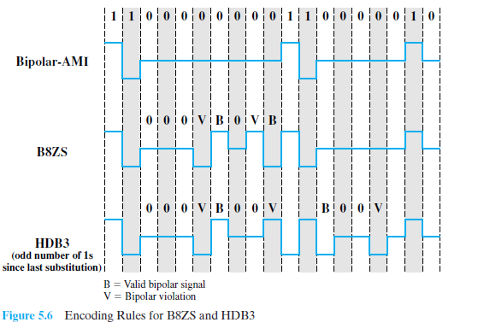
Two techniques are commonly used in long-distance transmission services; these are illustrated in Figure 5.6. A coding scheme that is commonly used in North America is known as bipolar
with 8-zeros substitution (B8ZS). The coding scheme is based on a bipolar-AMI.We have seen that the drawback of the AMI code is that a long string of zeros may result in loss of synchronization. To overcome this problem, the encoding is amended with the following rules:
• If an octet of all zeros occurs and the last voltage pulse preceding this octet was positive, then the eight zeros of the octets are encoded
• If an octet of all zeros occurs and the last voltage pulse preceding this octet was negative, then the eight zeros of the octet are encoded This technique forces two code violations (signal patterns not allowed in AMI) of the AMI code, an event unlikely to be caused by noise or other transmission impairment. The receiver recognizes the pattern and interprets the octet as consisting
of all zeros. A coding scheme that is commonly used in Europe and Japan is known as the
high-density bipolar-3 zeros (HDB3) code (Table 5.4). As before, it is based on the use of AMI encoding. In this case, the scheme replaces strings of four zeros with sequences containing one or two pulses. In each case, the fourth zero is replaced with a code violation. In addition, a rule is needed to ensure that successive violations are of alternate polarity so that no dc component is introduced. Thus, if the last violation was positive, this violation must be negative and vice verse
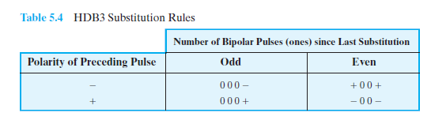
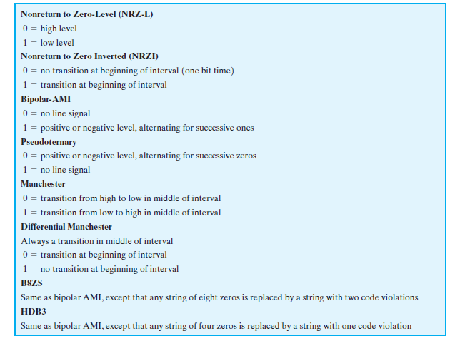
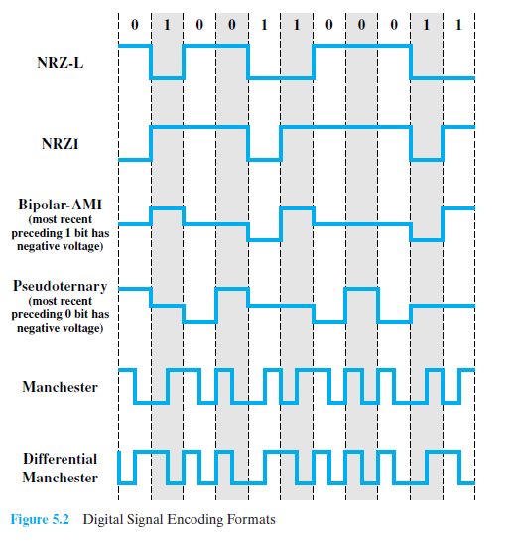
DIGITAL DATA, ANALOG SIGNALS
Amplitude Shift Keying
In ASK, the two binary values are represented by two different amplitudes of the carrier frequency. Commonly, one of the amplitudes is zero; that is, one binary digit is represented
by the presence, at constant amplitude, of the carrier, the other by the absence of the carrier (Figure 5.7a).The resulting transmitted signal for one bit time is
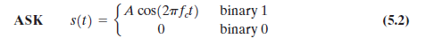
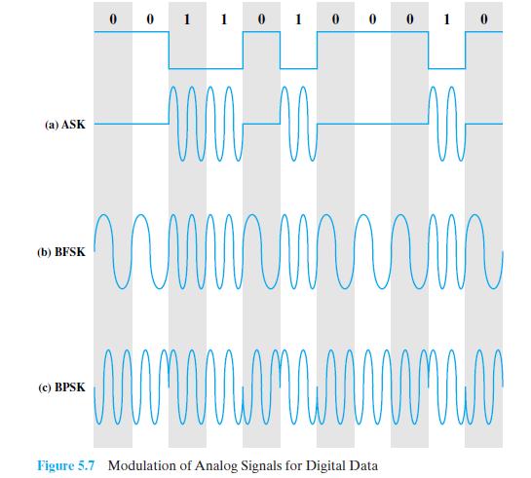
The ASK technique is used to transmit digital data over optical fiber. For LED (light-emitting diode) transmitters, Equation (5.2) is valid. That is, one signal element is represented by a light pulse while the other signal element is represented by the absence of light. Laser transmitters normally have a fixed “bias” current that causes the device to emit a low light level. This low level represents one signal element, while a higher-amplitude light wave represents another signal element

Frequency Shift Keying
The most common form of FSK is binary FSK (BFSK), in which the two binary values
are represented by two different frequencies near the carrier frequency (Figure5.7b).The resulting transmitted signal for one bit time is
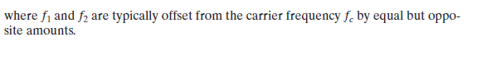
Phase Shift Keying
In PSK, the phase of the carrier signal is shifted to represent data. Two-Level PSK The simplest scheme uses two phases to represent the two binary digits (Figure 5.7c) and is known as binary phase shift keying. The resulting transmitted signal for one bit time is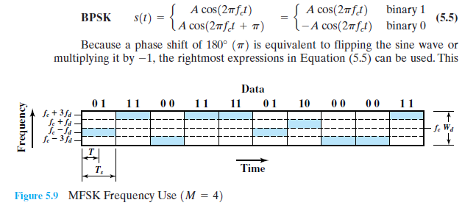
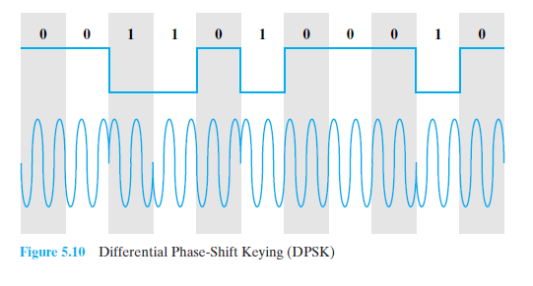

ANALOG DATA, DIGITAL SIGNALS
the process of transforming analog data into digital signals. Strictly speaking, it might be more correct to refer to this as a process of converting analog data into digital data; this process is known as digitization. Once analog data have been converted into digital data,
Pulse Code Modulation
Pulse code modulation (PCM) is based on the sampling theorem:
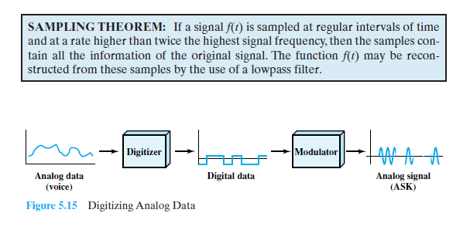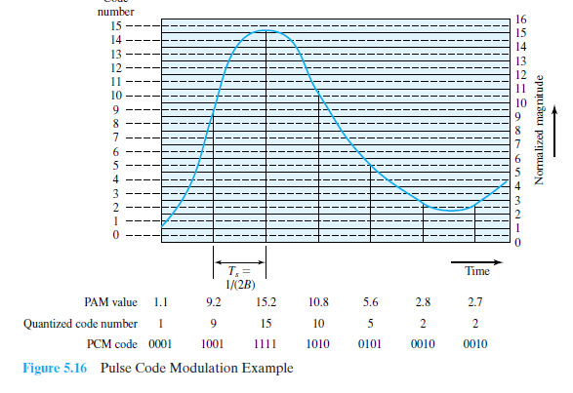
If voice data are limited to frequencies below 4000 Hz, a conservative procedure for intelligibility, 8000 samples per second would be sufficient to characterize the voice signal completely. Note, however, that these are analog samples, called pulse amplitude modulation (PAM) samples. To convert to digital, each of these analog samples must be assigned a binary code Thus, PCM starts with a continuous-time, continuous-amplitude (analog) signal, from which a digital signal is produced (Figure 5.17). The digital signal consists of blocks of n bits, where each n-bit number is the amplitude of a PCM pulse. On reception, the process is reversed to reproduce the analog signal. Notice, however, that this process violates the terms of the sampling theorem. By quantizing the PAM pulse, the original signal is now only approximated and cannot be recovered exactly. This effect is known as quantizing error or quantizing noise.
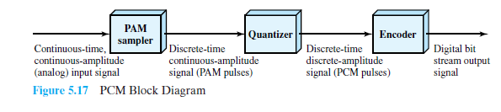
Delta Modulation (DM)
A variety of techniques have been used to improve the performance of PCM or to reduce its complexity. One of the most popular alternatives to PCM is delta modulation (DM).
With delta modulation, an analog input is approximated by a staircase function that moves up or down by one quantization level at each sampling interval where the staircase function is overlaid on the original analog waveform. The important characteristic of this staircase function is
that its behavior is binary: At each sampling time, the function moves up or down a constant amount Thus, the output of the delta modulation process can be represented as a single binary digit for each sample. In essence, a bit stream is produced by approximating the derivative of an analog signal rather than its amplitude: A 1 is generated if the staircase function is to go up during the next interval; a 0 is generated otherwise. The transition (up or down) that occurs at each sampling interval is chosen so that the staircase function tracks the original analog waveform as closely as possible. At each sampling time, the analog input is compared to the most recent value of the approximating staircase function. If the value of the sampled waveform exceeds that of the staircase function, a 1 is generated; otherwise, a 0 is generated. Thus, the staircase is always changed in the direction of the input signal. The output of the DM process is therefore a binary sequence that can be used at the receiver to reconstruct the staircase function. The staircase function can then be smoothed by some type of integration process or by
passing it through a low pass filter to produce an analog approximation of the analog input signal.
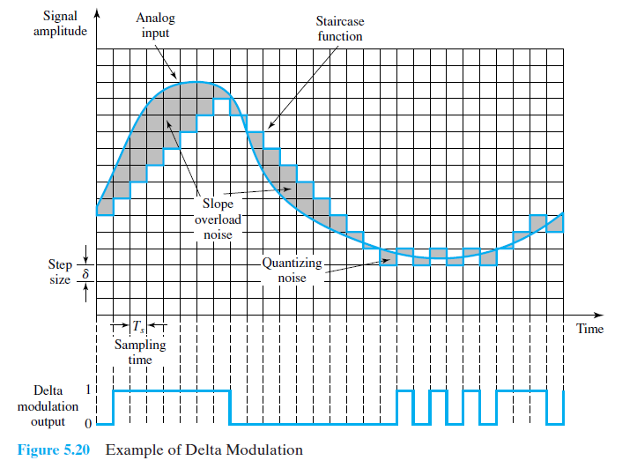
ANALOG DATA, ANALOG SIGNALS
Modulation has been defined as the process of combining an input signal m (t) and a carrier at frequency to produce a signal s (t) whose bandwidth is (usually) centered on for digital data, the motivation for modulation should be clear: When only analog transmission facilities are available, modulation is required to convert the digital data to analog form. The motivation when the data are already analog is less clear. After all, voice signals are transmitted over telephone lines at their original spectrum (referred to as baseband transmission). There are two principal reasons for analog modulation of analog signals:
• A higher frequency may be needed for effective transmission. For unguided transmission, it is virtually impossible to transmit baseband signals; the required antennas would be many kilometers in diameter.
• Modulation permits frequency division multiplexing, an important technique

